Sewage Spills Project: Report 1

Introduction and Motivation
There has been much recent controversy regarding the water industry, with it’s high dividends amidst growing pollution problems (BBC 2024; Financial Times, 2024). The Labour Party suggested that hospital admissions of waterborne diseases has increased significantly over the past decade, 60% since 2010, supporting their proposals to reform the water industry (The Guardian, 2024). It is thus justified for us to look more closely at the water industry, and its impact on public health.
This initial investigation into how sewage spills are related to E. coli cases has not found evidence for a significant relationship; in several simple panel data models we do not find a significant positive association between monthly E. coli incidence and either sewage spill duration or number of sewage spills in the local area. The present study was designed to help explore the limits of the data we currently possess, and understand the processes required to analyse sewage spills in relation to other public health outcomes and firm value. The lack of identification of dry spills limits the validity of the results so far, alongside other factors: the EDM data being limited to 2 English companies; the NHS data being limited to acute trust level, rather than hospital level; and some limitations to the methodology involving construction of buffers around NHS trusts.

Data
We make use of individual sewage spill data from Southern and Wessex Water and E coli incidents data from the NHS, located spatially using EDM maps from the Rivers Trust and web-scraped addresses from the NHS website respectively. E coli incidence data is available from 2021 onwards, and Southern and Wessex individual spill data are available from 2017 and 2022 respectively. Our resulting panel data is unbalanced over the 3-year period 2021 to 2023.
The EDM data from the two Water and Sewage companies provides the start and stop times for each spill event, alongside its accompanying discharge period and duration, the former referring to the difference between start and stop times and the latter being the amount of time sewage was continuously released during the period. Each company has different ways to uniquely identify each monitor, which can be used to locate them using EDM maps. The data has not yet been matched to HadUK data, which includes daily rainfall across the UK as a 1km grid. This will allow dry spills to be identified.

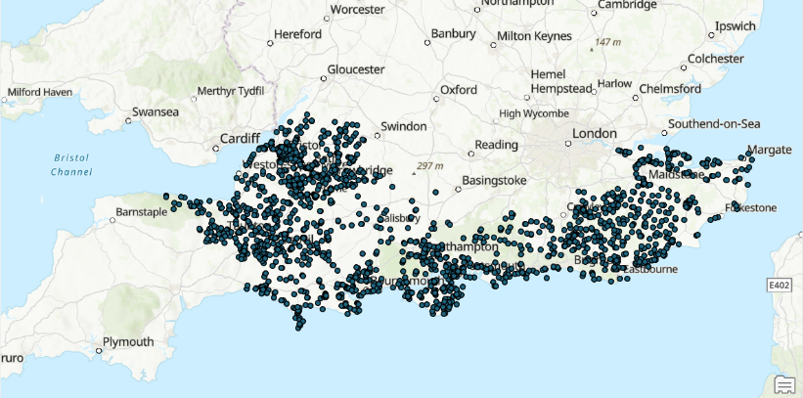
Figure 1: Southern and Wessex Water EDM locations

The health data used, to help inform our understanding of other available public health outcome data related to sewage, is NHS data on E.coli incidence. This data provides monthly counts of E.coli cases by different organisation levels within the NHS. The most granular data provided are those at CCG and acute trust level. I chose to analyse the acute trust incidence data, since there exist more acute trusts than CCGs and CCGs have been replaced by larger ICBs which implies CCG-level data may not continue to be published (British Medical Association, 2024). The data is also provided by “onset” – categorising cases based on how the patient is infected. Such categories include community-onset and hospital-onset, but since a high proportion of cases are labelled “unknown” in onset, we proceed by including all cases. This may limit analysis if hospital-onset cases are certainly not related to sewage spills, however this seems somewhat unlikely. The data does not include any coordinate reference for mapping (for example latitude and longitude) but using NHS specific codes for each acute trust, we can scrape the postcodes from the NHS website, and geocode them using ArcGIS. The process led to some tied matches, which are easily resolved. There exist some third-party maps, which provide boundaries for CCGs – however, they are not wholly transparent about where they source their data, so this paper avoids using their maps instead of the NHS postcodes.
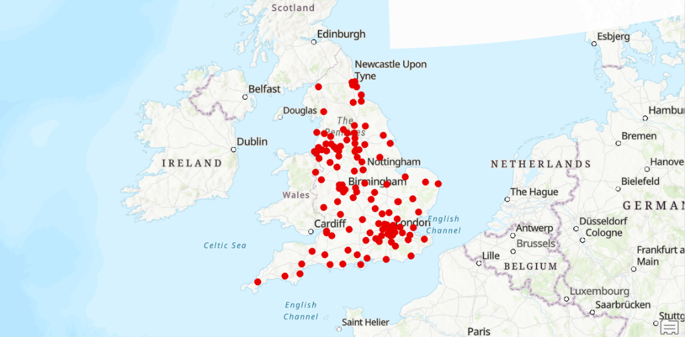
Figure 2: NHS acute trust postcode locations

The justification for using E coli incidence as our dependent variable in this initial study is that, unlike other diseases related to faecal contamination of waters such as norovirus (Sojobi & Zayed, 2022), there exists readily available data at a sub-regional level, aggregated monthly rather than yearly. Furthermore, E coli pathogen concentrations have been widely used as an indicator for water quality (Rodrigues et al, 2016), and have been investigated in relation to sewer overflows. Garcia-Garcia et al (2021) find peak discharges into the Dart Estuary may cause a 10-fold increase in E coli bacterium concentrations. Guidelines exist to the concentrations of E coli bacterium that pose a health risk to humans (Rodrigues et al, 2016), primarily through contact with contaminated water (Garcia-Garcia et al, 2021; Sojobi & Zayed, 2022). In addition, several recent articles have emphasised the risk of E.coli resulting from sewage spills amidst severe incidents and shellfish site closures (BBC, 2023;The Guardian, 2023; Surfers Against Sewage [accessed 2024]).
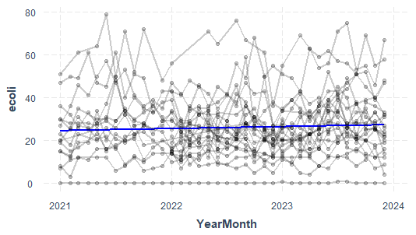
Figure 3: monthly E coli incidence 2021-2023, (blue = mean)
Figure 3 shows E coli incidence over the three years is quite stationary, perhaps with a slightly upward-sloping mean. There also exists no obvious changes in variance across our period.

Methodology and Results
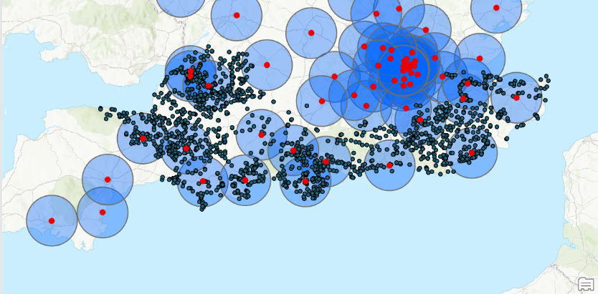
The two data, individual spill and E.coli incidence, differ in time period and there is, to the best of my knowledge, no definite way to determine which NHS acute trust is responsible for cases relating to spills at each CSO location. I thus construct buffers around each NHS acute trust location. Somewhat crudely we estimate 20km radius buffers could approximate the jurisdiction of each NHS acute trust; There are 124 NHS acute trusts, covering the UK’s 243 km squared land mass. In reality, each acute trust differs in size. We find the CSOs that lie within these buffers and aggregate their spill data.
Figure 4: Buffers (blue) 20km in radius constructed around NHS acute trust postcodes

We count the number of spill events occurring within each NHS acute trust buffer each month to get the spill count. This is investigated alongside aggregated spill duration in relation to monthly E.coli incidence. To aggregate the spill duration within each NHS buffer, we assume the duration of each spill is uniformly distributed across the spill period. With this assumption, we can interpolate how much of each spill duration is attributable to each month, when a spill event spans across months.
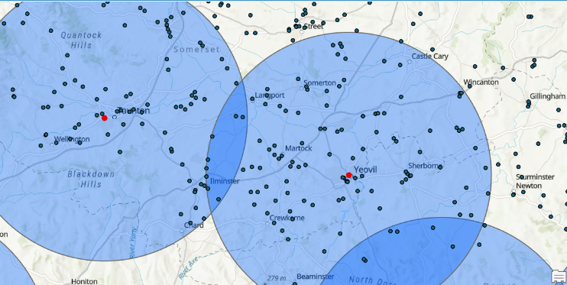
Several EDMs lie in the buffer of two acute trusts. In these cases, we assign the EDM to its closest NHS acute trust.
Figure 5: Overlap between some NHS buffers

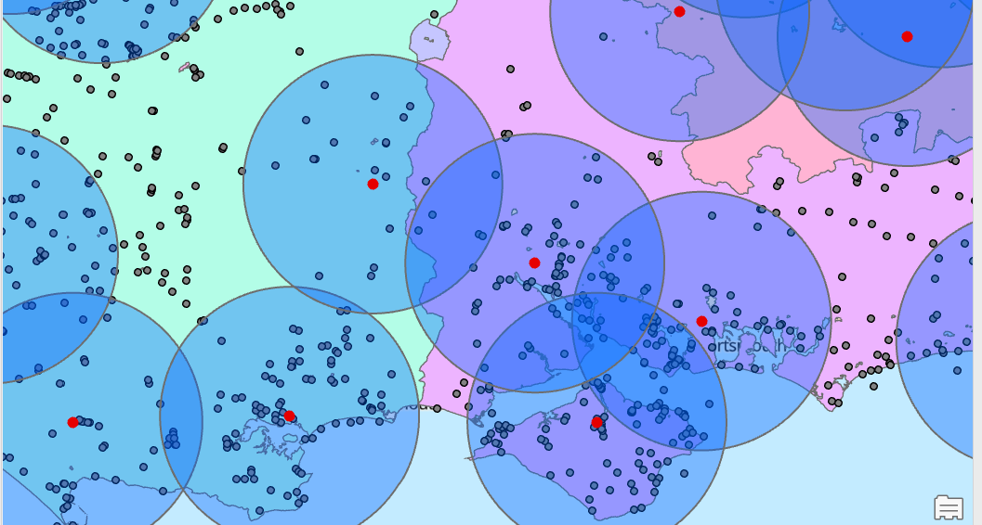
We find that one buffer straddles the border between Southern and Wessex Water such that it includes EDMs from both companies, shown in figure 6. This would bias our regression results, since in 2021 the aggregated spill duration and spill counts for this NHS acute trust would only include those from Southern Water, compared to the following year when Wessex Water spills would also be included, due to data availability. Therefore, the 2021 observations for this acute trust are removed, making our panel more unbalanced. Our resulting panel data has 664 observations, from 23 NHS acute trusts, each with 12 to 36 time periods.
Figure 6: a buffer has both southern and Wessex EDMs, an issue due to the unbalanced panel

Table 1
 | E.coli |  | Duration | Count
Mean | 26.11849 |  | 1225.092 | 463.7837
Std Dev | 14.56936 |  | 3226.924 | 2161.322
Min | 0 |  | 0.07 | 1
Max | 79 |  | 45583.09 | 40123

Table 1 provides descriptive statistics for our variables

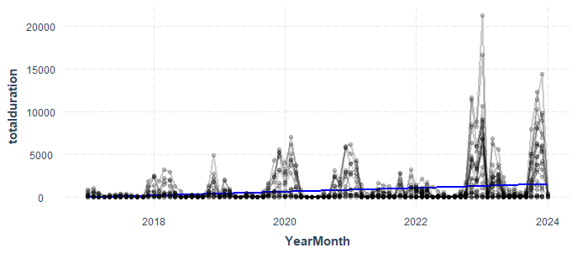
We use standard panel data models to analyse these newly constructed monthly spill variables’ association with E coli incidence. But firstly, by plotting the data, we see some heteroskedasticity in both independent variables (see Figure 7), and notably, seasonality in spill durations. This could be due to wetter weather during the autumn and winter months leading to longer discharges. Therefore, the seasonality may be reduced when we identify and isolate dry spills. We should be careful interpreting our current results, given these variables may be non-stationary, meanwhile our dependent variable is likely stationary. However, since we only have 3 years of data in our panel, non-stationarity may be less of an issue, particularly when we add more data from other water companies, extending the N dimension relative to the T dimension (Baltagi, 2021).
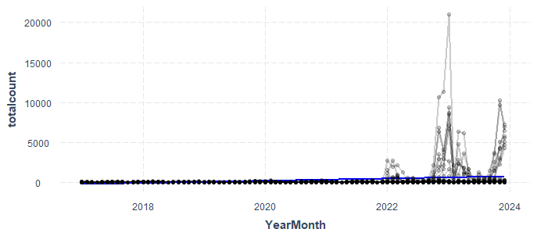
Figure 7: plots of spill duration and count, each with mean in blue
The specifications estimated here are as follows:
$$E_{at}=α+βS_{at}+α_{a}+α_{t}+ε_{at}$$
where $E_{at}$ is the incidence of E coli at NHS acute trust $a$ at time $t$, measured as year-months from 2022 to 2024. $S_{at}$ is the spill variable - aggregate duration or aggregate count of all spills in the buffer area of acute trust $a$ from Southern Water or Wessex Water companies – at time $t$.
Specifications (1) and (2) do not contain fixed effects $α_{a}$ or $α_{t}$. Therefore, a negative $β$ in (1) and (2) can be interpreted as E coli incidence is greater during low spill periods. Specifications (3) and (4) contain $α_{a}$ but not $α_{t}$. A negative $β$ in (3) can be interpreted as an acute trust has more E coli incidence during low spill periods. Figure 3 shows that there is some seasonality in E coli incidence. Including time fixed effects controls for seasonality in specifications (5), (6) and (7). A positive $β$ in (5), (6) and (7) can be interpreted as an acute trust is more likely to have E coli incidence when there is more than usual spillage activity in the period.
Table 2 shows our initial models: models (1) and (2) are pooled OLS models, (3) and (4) include acute trust fixed effects, and models (5), (6) and (7) include both acute trust and time fixed effects. We refrain here from including both monthly spill duration and count in the same specifications, since it is unclear that they would be picking up on different effects and they have relatively high correlation (SEE A1), albeit perhaps not sufficient to pose multicollinearity concerns in our estimation. We see that the spill duration tends to have a negative coefficient but has a small positive coefficient when we account for time fixed effects. Furthermore, the standard errors are yet to be corrected, so we shouldn’t consider this result significant currently. On the other hand, the number of spills in an NHS acute trust area tends to have a positive coefficient across our models, albeit only perhaps significant in our fixed effects model with time dummies (6). This result does not appear robust across all models, with the pooled OLS (2) assigning a negative coefficient.
Model (7) counts only the 10% of spills that are longest in duration. This is intended to focus our estimation on the most significant spills, as shorter spills may not cause sufficient pollution to pose an E. coli risk. There is an insignificant small positive coefficient when time and acute trust fixed effects are included. We find that the shortest spill in this subset of our data is 2.3 hours, meaning 90% of spills are shorter than this. The prevalence of short spills in our data suggests adopting the standard 12-24 spill count method may be beneficial in analysing how the number of spills is related to E. coli incidence.

Table 2
Variables | Pooled  (1) |  | Pooled  (2) |  | Fe  (3) |  | Fe  (4) |  | Fe  (5) | Fe  (6) |  | Fe  (7)
Duration | -0.000107*** |  |  |  | -0.000222* |  |  |  | 0.000069
Count |  |  | -0.000600* |  |  |  | 0.0000029 |  |  | 0.000333* |  | 0.004732
N | 664 |  | 662 |  | 664 |  | 662 |  | 664 | 662 |  | 608
Adj-R-sqr | 0.024 |  | 0.003 |  | -0.030 |  | -0.036 |  | -0.095 | -0.090 |  | -0.104
 |  |  |  |  |  |  |  |  |  | ***p<0.001, **p<0.01, *p<0.05

Although the standard errors do not yet account for the forms of heteroskedasticity we observe in the spill duration and spill count variables, we can infer that our results do not yet support the hypothesis that sewage spills in general across the Southern UK are strongly related to E coli incidence. An explanation could be that the concentrations of E coli bacterium (whose data is not readily available (Garcia-Garcia et al, 2016)) resulting from sewage spills is not often high enough to induce a significant health risk to most people, given their uses of UK water bodies.
I refrain from including lags on the independent variables since E coli symptoms are known to commonly develop within 4 days of contact with or consumption of contaminated water and food (NHS, 2024). In addition, it is believed waters tend to return to safe conditions after 3 days, although depending on certain water conditions it may take longer (Government of Western Australia, [accessed 2024]). Therefore, including a month lag to capture delayed effects of sewage spills has little justification.
There are several reasons the current analysis may not be capturing the true relationship between sewage spills and E coli cases. Firstly, dry spills not being identified could explain our spill duration variable being unrelated to E coli cases, since dry spills can hold a much higher concentration of pathogens compared to more diluted wet spills. As explained by Rodrigues et al (2016), the concentration of E coli bacteria matters for risks posed to public health. In addition to rainfall, other environmental condition data such as water salinity may help debias results, given their impact on the peak E coli concentrations resulting from sewage spills (Garcia-Garcia et al, 2021).
Furthermore, E coli cases are not strictly caused by contact with contaminated water. Garcia-Garcia et al (2021) mention E coli transmission through food – in particular shellfish. Although this is still related to sewage spills (which contaminate shellfish), it means that our NHS buffers may not approximate the impacts of sewage spills well. A sewage spill in one region could cause E coli cases in a distant region, through the transportation of contaminated foods, implying spillover effects. On the other hand, our current data may not be granular enough to capture the impact of sewage spills on E coli incidence: individual hospital admissions data could give more insight into E coli and other public health outcomes.
The limitations of the individual spill data may also have had an impact. As more data becomes available from other water and sewerage companies, our panel data will become more balanced, and we can get a better idea of the properties of the data, informing a more robust econometric methodology. Some buffers created around NHS acute trusts are intuitively missing data from other WaSCs; as seen in Figure 8, NHS acute trusts near the border of Southern and Wessex Water and other water companies may bias results by receiving E coli cases caused sewage spills we do not currently have information on.
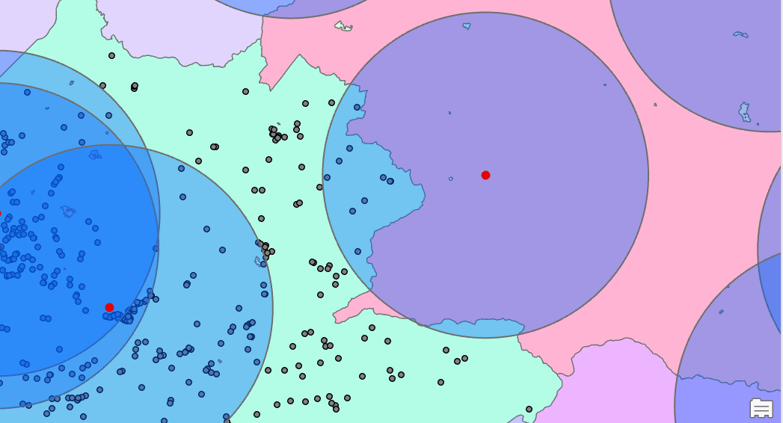
Figure 8: an example of a buffer that may be biasing our results: it is mostly in another water company’s area – but still included due to some overlap with Wessex. If there are significant spills from the other company causing high E coli incidence – our results may be biased by this.

References
Baltagi, B.H. (2021). Nonstationary Panels. In: Econometric Analysis of Panel Data. Springer Texts in Business and Economics. Springer, Cham. https://doi.org/10.1007/978-3-030-53953-5_12
BBC. (2023) Sewage: Mum says daughter got E. coli after swimming in polluted sea, Available from: https://www.bbc.co.uk/news/uk-wales-66709904 (Accessed 30/07/24)
BBC. (2024) Raw sewage spills into England rivers and seas doubles in 2023, Available from: https://www.bbc.co.uk/news/science-environment-68665335 (Accessed 25/07/24)
British Medical Association. (2024) Integrated care systems (ICSs), Available from: https://www.bma.org.uk/advice-and-support/nhs-delivery-and-workforce/integration/integrated-care-systems-icss (Accessed 30/07/24)
Financial Times. (2024) UK watchdog sends fresh warning to water utilities over dividends, Available from: https://www.ft.com/content/c869586f-8a98-4ab1-a4fd-8e3581c164e2 (Accessed 28/07/24)
Garcia-Garcia, L.M, Campos, C.J.A, Kershaw, S, Younger, A & Bacon, J.. (2021) Scenarios of intermittent E. coli contamination from sewer overflows to shellfish growing waters: The Dart Estuary case study, Marine Pollution Bulletin, 167
Government of Western Australia (Accessed 2024) Sewage Spills, Available from: https://www.healthywa.wa.gov.au/Articles/S_T/Sewage-spills (Accessed 30/07/24)
NHS. (2024) Escherichia coli (E. coli) O157, Available from: https://www.nhsinform.scot/illnesses-and-conditions/infections-and-poisoning/escherichia-coli-e-coli-o157/ (Accessed 30/07/24)
Rodrigues, V.F.V, Rivera, I.N.G, Lim, K & Jiang, S.C (2016) Detection and risk assessment of diarrheagenic E. coli in recreational beaches of Brazil, Marine Pollution Bulletin, 109
Sojobi, A.O. & Zayed, T. (2022) Impact of sewer overflow on public health: A comprehensive scientometric analysis and systematic review. Environmental Research, 203
Southern Water. (Accessed 2024) Individual Spill Data, Available from: https://www.southernwater.co.uk/about-us/environmental-performance/healthy-rivers-and-seas/flow-and-spill-reporting/
Surfers Against Sewage (Accessed 2024) The risks of mixing with sewage, Available from: https://www.sas.org.uk/water-quality/water-quality-facts-and-figures/the-risks-of-mixing-with-sewage/ (Accessed 30/07/24)
The Guardian. (2024) Hospital admissions for waterborne diseases in England up 60%, report shows, Available from: https://www.theguardian.com/environment/2024/mar/29/hospital-admissions-for-waterborne-diseases-in-england-up-60-report-shows (Accessed 25/07/24)
The Guardian. (2024) Sewage spills blamed as E coli forces Cornish shellfish sites to close, Available from: https://www.theguardian.com/environment/2023/may/26/sewage-spills-blamed-e-coli-forces-cornish-shellfish-sites-to-close (Accessed 30/07/24)
The Rivers Trust. (Accessed 2024) Sewage Map, Available from: https://corporate.wessexwater.co.uk/our-purpose/rivers-and-coastal-waters/storm-overflows
UK Health Security Agency. (Accessed 2024) E. coli bacteraemia: monthly data by location of onset, Available from: https://www.gov.uk/government/statistics/e-coli-bacteraemia-monthly-data-by-location-of-onset
Wessex Water. (Accessed 2024) Individual Spill Data, Available from: https://corporate.wessexwater.co.uk/our-purpose/rivers-and-coastal-waters/storm-overflows

Appendix
A1
Table A1
 | E.coli |  | Duration | Count
E.coli | 1 |  | -0.1342209 | -0.05245181
Duration |  |  | 1 | 0.73258714
Count |  |  |  | 1

This table is a correlation matrix for our dependent and independent variables. We see negative correlations between E. coli incidence and monthly spill duration and number. The strong positive correlation between duration and count, 0.73, shows these variables are strongly related, and including both in a regression could be inefficient.

Table A2
Variables | Pooled  (1) |  | Pooled  (2) |  | Fe  (3) |  | Fe  (4) |  | Fe  (5) | Fe  (6) |  | Fe  (7) |  | Pooled  (8) |  | Pooled  (9) |  | Be  (10) |  | Fe  (11) |  | Fe  (12)
Duration | -0.000107*** |  |  |  | -0.000222* |  |  |  | 0.000069 |  |  |  |  |  |  | -0.001362*** |  | -0.006684 |  | -0.000433** |  | -0.000139
Count |  |  | -0.000600* |  |  |  | 0.0000029 |  |  | 0.000333* |  | 0.004732 |  | -0.022901*** |  | 0.000620 |  | 0.002053 |  | 0.000464* |  | 0.000425
N | 664 |  | 662 |  | 664 |  | 662 |  | 664 | 662 |  | 608 |  | 608 |  | 662 |  | 662 |  | 662 |  | 662
Adj-R-sqr | 0.024 |  | 0.003 |  | -0.030 |  | -0.036 |  | -0.095 | -0.090 |  | -0.104 |  | 0.021 |  | 0.02 |  | 0.06 |  | -0.03 |  | -0.09
 |  |  |  |  |  |  |  |  |  |  |  |  |  |  |  |  |  | ***p<0.001, **p<0.01, *p<0.05

A2

Table A2 presents all regression results for this report. Models (1) and (2) are pooled OLS for each independent variable separately; (3) and (4) add in acute trust fixed effects; (5) and (6) add tiem fixed effects in addition to the acute trust fixed effects. Models (7) and (8) are each two-way fixed effect and pooled OLS specifications respectively, that use only the 10% longest spills when counting spills over each month. (9), (10), (11) and (12) are each pooled OLS, a between estimator, one-way fixed effect and two way fixed effect regressions that include both independent variables together.

We make use of maps from the River’s trust – who provide their map data in convenient CSV format with data tracing back several years, allowing EDMs thar have since closed to still be located (River’s Trust, [accessed 2024]).
CCGs were organisational bodies that mostly preside over local NHS funding, and acute trusts worked with CCGs to provide the hospital services to the local population.
Referring to the NHS regions – which are too broad for analysis.
The same assumption and aggregation process will be useful for when other data is available. For example, if daily hospital admissions of diseases become available, we can interpolate spill duration across days in the same way.
All statistical analysis was conducted using R 4.2.1
See A2 for all models, including those with both independent variables and other models using the 10% longest spills only

